Manto, Saadat Hasan (1912-1955)
M. Asaduddin

‏‏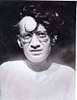 Saadat Hasan Manto( و‏‏سعادت حسن منٹ, 1912–1955), one of the foremost writers of the Indian subcontinent in Urdu is, by common consent, the most accomplished practitioner of the short story form in South Asia. He wrote short stories, sketches, portraits, essays, screen plays, seven collections of radio plays and a novel.
Born in a typical middle class Muslim family of Samrala, Punjab, to a conservative, domineering father and a gentle mother, he showed no interest in studies at school. Luckily he chanced upon a mentor, Abdul Bari Alig, a dilettante writer and journalist, who introduced him to English, Russian and French writers – Oscar Wilde, Chekhov, Pushkin, Maupassant, Victor Hugo and others. Manto was so taken up with these writers that he translated Victor Hugo’s The Last Days of a Condemned Man into Urdu, and then Oscar Wilde’s Vera, both the works imbued with revolutionary intent. His apprenticeship as a translator prepared Manto to try his hand at creative writing and he came out with his first story, “Tamasha” which he published under a pseudonym in the journal, Khalq. However, after a series of false starts he really came into his own as a writer after he came to Bombay in 1936 to edit a film magazine, Musawwir.
The film world excited Manto’s imagination and he loved being a part of it. However, he knew that writing for films could not offer him the deep satisfaction of serious literature of lasting impact. He was alive to the changes in literary sensibility following the endeavours of the Progressive Writers Movement, inaugurated by Premchand in 1936. Obscenity charges were leveled against him for his candid treatment of sex and he was tried several times in the court.
The event that shook Manto’s confidence in himself and in his fellow human beings was the partition of India. His efforts to come to grips with this terrible human tragedy produced stories that looked at the violence, slaughter and savagery of Partition straight in the face without rhetorical consolation. “Toba Tek Singh” has acquired an iconic, almost mythical status as an allegory of the absurdity of shadow line boundaries and phantom borders. “Cold Meat”, “Open It” and “Saha’e” depict the unmitigated brutality of partition where neighbours turned against each other, reminding one of Primo Levi’s stark portrayal of the German holocaust. The 32 vignettes under the title, Siyah hashiye (Black Margins) are notable for their macabre humour and subversive intent.
Despite his contempt for politicians Manto was remarkably prescient. In an open letter to Nehru (http://www.urdustudies.com/pdf/11/15pundit.pdf) he spoke about the cavalier way the country was divided, the problems faced by the Kashmiris, the water-dispute between India and Pakistan and the plight of the Urdu language in post-partition India. The post-partition politics of attrition between India and Pakistan has been treated with panache in his story “Dog of Tithwal” where “even a dog has to declare whether he is a Pakistani or Hindustani.” In his series of “Letters to Uncle Sam” he figures out the contours of international politics in the context of India-Pakistan hostility.
Discussions of Manto often do not mention his heartwarming wit and humour. This quality lifts his bleak and stark tales from their atmosphere of gloom and makes them invaluable human documents of our times.

1912 1933 1936 1944 1948 1955
| | | | | |
Born met Bari Alig Arrival in Bombay tried for obscenity for “Boo” Left Bombay for Pakistan Death
Atishparay

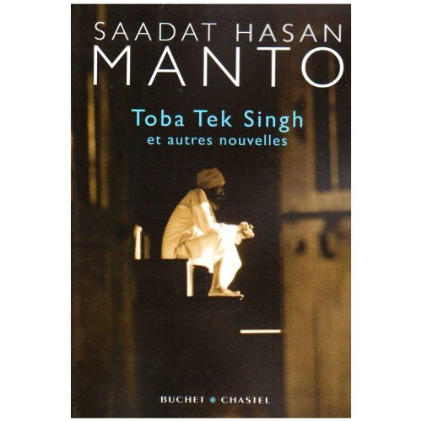
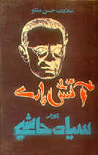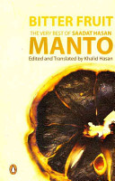
Urdu Original Manto in English translation Manto in French translation

Manto’s Works in Original Urdu
- Atishparay (Nuggets Of Fire), 1936
- Manto Ke Afsanay (Stories of Manto), 1940
- Dhuan (Smoke), 1941
- Afsane Aur Dramay (Fiction and Drama) - 1943
- Chughad (Owl), 1948
- Lazzat-e-Sang (The Taste Of Rock), 1948
- Siyah Hashiye (Black margins),1948
- Badshahat Ka Khatimah (The End of Kingship), 1950
- Khali Botlein (Empty Bottles), 1950
- Nimrud Ki Khudai (Nimrod, The God), 1950
- Thanda Gosht (Cold Meat), 1950
- Yazid ,1951
- Pardey Ke Peechhey (Behind The Curtains), 1953
- Sarak Ke Kinarey (By the Roadside), 1953
- Baghair Unwan Ke (Without a Title), 1954
- Loud Speaker, 1955
- Baghair Ijazat (Without Permission), 1955
- Burquey, 1955
- Phundney (Tassels), 1955
- Sarkandon Ke Peechhey (Behind The Reeds),1955
- Shaiytan (Satan), 1955
- Shikari Auratein (Women On the Prowl), 1955
- Ratti, Masha, Tolah, 1956

Manto’s Works in Translation
- Stars from Another Sky: The Bombay Film World of the 1940s, tr. by Khalid Hasan. Delhi: Penguin India, 2000.
- For Freedom’s Sake: Saadat Hasan Manto: Stories and Sketches, tr., M Asaduddin. Karachi : Oxford University Press, 2001
- Bitter Fruit:The Very Best of Saadat Hassan Manto, edited and tr. by Khalid Hassan, Penguin, 2008.
- Naked Voices: Stories and Sketches by Manto, Ed. and tr. by Rakhshanda Jalil. Delhi: Indian Ink & Roli Books, 2008.
- Toba Tek Singh et autres nouvelles, traduites de l'ourdou (Inde et Pakistan) par Alain Désoulières, Paris Buchet Chastel, 2008
Critical Works on Manto in English
- Life and Works of Saadat Hasan Manto, ed., Alok Bhalla, Shimla: Indian Institute of Advanced Study, 1997.

